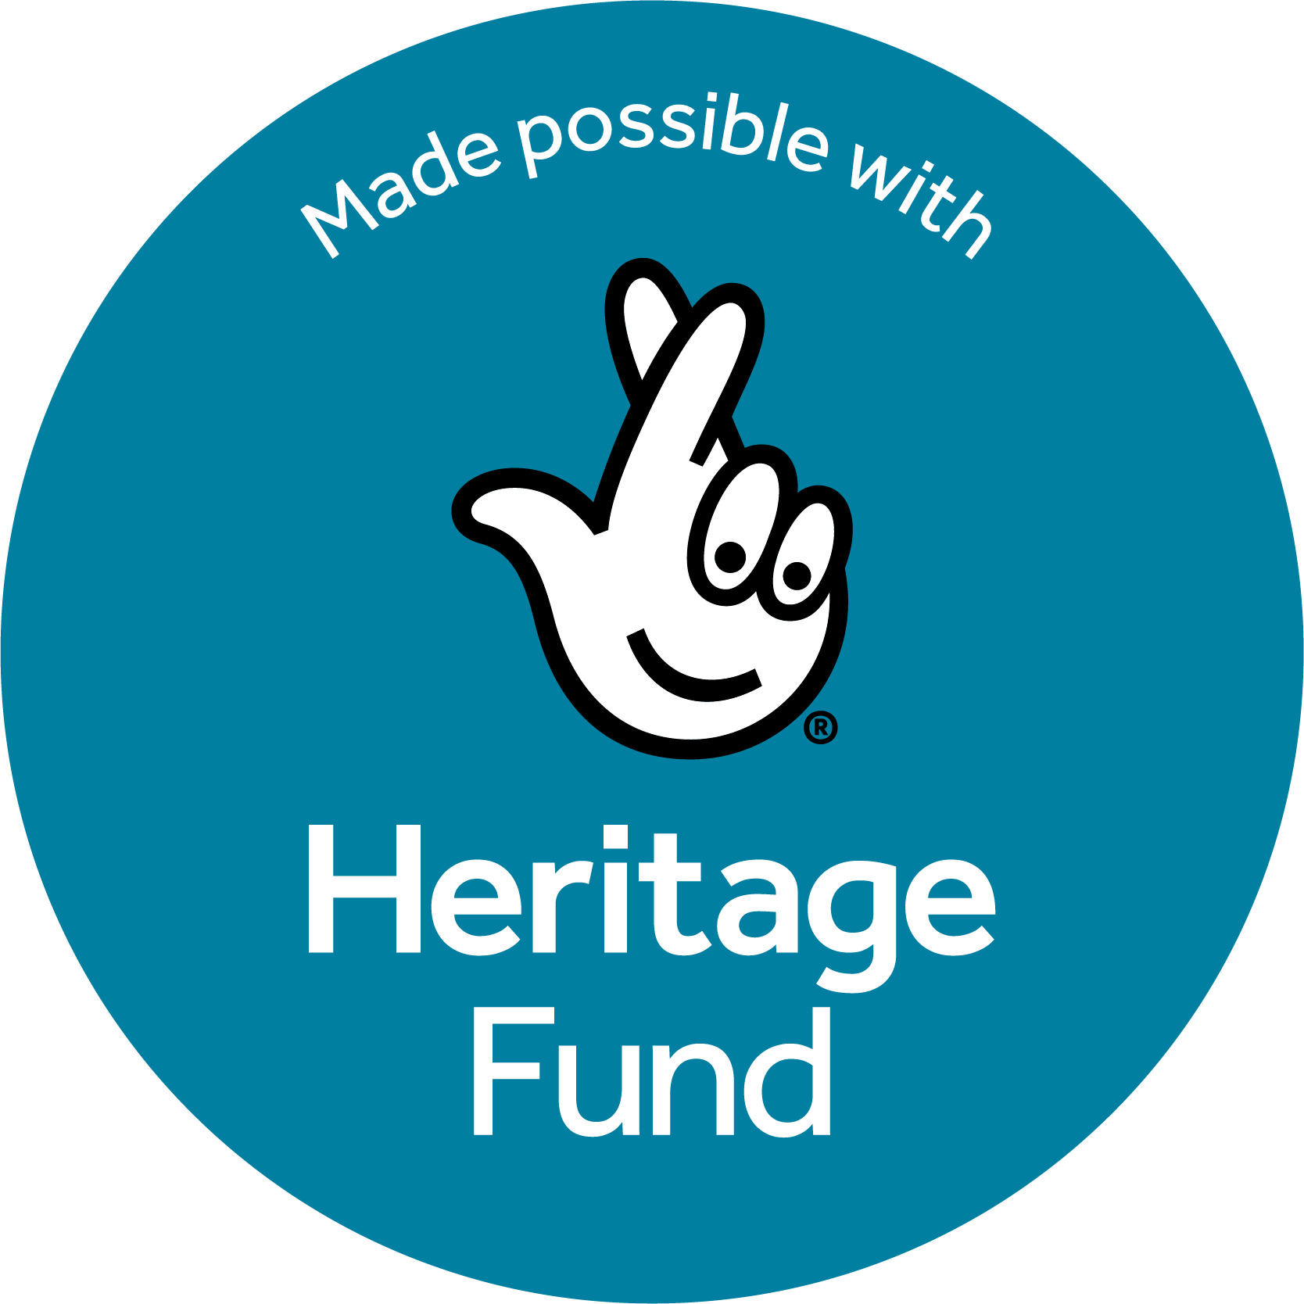

Volunteer Coordination Officer – Shaping a Resilient Future (0.6 FTE) Application Pack

Contents

Job description 1
Person specification 3
Equality, diversity and inclusion statement 3
About Heritage Crafts 4
Main conditions of employment 6
How to apply 7
Application form 8

Job description

Job Title: Volunteer Coordination Officer – Shaping a Resilient Future (part time)

Reports to: Executive Director

Contract: 0.6 FTE for 18 months

Location: Remote working from home in UK

Shaping a Resilient Future:
- Heritage Crafts has received a National Lottery Heritage Fund grant to capitalise on the heightened interest in traditional craftsmanship in the UK. Made possible by money raised by National Lottery players, the two-year project will increase the charity’s capacity to support craft skills as a vital part of the UK’s heritage.
- With the support of the National Lottery Heritage Fund, Heritage Crafts will invest in additional staff and freelance consultants to help it achieve long-term sustainability. This will include broadening and diversifying its funding and supporter base, mobilising a network of volunteers all around the country, and ensuring that equity and diversity remain at its core.

Principal purpose:
- To develop and implement a volunteering strategy for Heritage Crafts, as well as accompanying volunteer policies and procedures, in collaboration with staff and Trustees.
- To recruit and manage volunteers to work on behalf of Heritage Crafts and to represent the organisation at real-world and online events.

Key tasks and responsibilities:
Key tasks and responsibilities appropriate to this post are listed below:

Project requirements
- Develop and implement volunteering strategies, recruitment processes, policies and procedures, in collaboration with staff and Trustees.
- Recruit volunteers through various channels to work on behalf of Heritage Crafts, in accordance with the strategy etc, including organising and running volunteer recruitment events in collaboration with colleagues.
- Provide a point of contact for volunteers, coordinating and overseeing their activities, and providing advice and guidance as required.
- Undertake appropriate measures to ensure that all activities carried out by volunteers in connection with Heritage Crafts comply with its expectations, values and key messages.
- Monitor and report on the performance of volunteers, and identify any causes of concern to the Executive Director at the earliest possible opportunity.
- Provide content for the website, social media posts and press releases to publicise and celebrate the contribution of volunteers.
- Develop material and electronic resources for volunteers to use while representing Heritage Crafts at real-world events and online, including banners, leaflets, presentations etc.
- Organise and run volunteer-facilitated member recruitment events and other volunteer initiatives in collaboration with colleagues.
- Coordinate Heritage Crafts’ Young Ambassadors programme.
- Maintain and grow the Heritage Crafts’ database, inputting and updating details of volunteers following Data Protection compliance and best practice.
- Be subject to disclosure and barring checks and other safeguarding measures in order to work safely with young people and vulnerable adults.

General requirements
- Gain a working knowledge of Heritage Crafts and be well briefed in its key aims, objectives and current projects.
- Maintain positive communications with stakeholders, including but not limited to volunteers and volunteer-support agencies.
- Process contact and personal information in accordance with Heritage Crafts’ Data Protection Policy.
- Assist in updating the main Heritage Crafts website as required.
- Undertake any other tasks, training or appraisal recommendations as appropriate.
- Provide administrative cover for the other staff members as and when required.

Person specification

Essential criteria
- Experience of working with volunteers in a professional capacity.
- High standard of general administrative skills, including routine office tasks such as answering emails, keeping records, processing data, writing reports, organising meetings etc.
- High level of interpersonal, written and verbal communication skills.
- Experience of building good working relationships with a wide range of people from different walks of life.
- High level of IT literacy, including word processing, email and spreadsheets.
- Interest in traditional crafts or the heritage sector.
- Ability to be self-motivated, self-directed and well organised.
- Willingness to work remotely for extended periods of time.
- Ability to adapt to new working methods as the organisation grows and changes, particularly in IT.
- Willingness to work evenings or weekends on occasion.
- Willingness to travel, including overnight stays on occasion.
- Access to a reliable broadband connection and contactable by phone during working hours.
- Commitment to adhere to and champion Heritage Crafts’ values.
- Commitment to increasing diversity and representation.

Desirable criteria
Experience of:
- Working in a charitable/not-for-profit organisation.
- Managing volunteers and/or developing volunteering strategies, policies or procedures.
- Facilitating young people’s involvement with an organisation or business.
- Event management.
- Using a Customer Relationship Management (CRM) system.
- Working in the traditional crafts or heritage sector.

Equality, diversity and inclusion statement

Heritage Crafts:
- is committed to encouraging equality, diversity and inclusion among our members, staff and volunteers.
- aims to be representative of all sections of society and expects our staff, trustees, associates and anyone involved in the organisation to respect our values.
- goes beyond legislative compliance to make equality, fairness and diversity integral to everything we do. We opposes all forms of unlawful and unfair direct or indirect discrimination.

Our full Equality, Diversity and Inclusion policy can be viewed here.

About Heritage Crafts

Heritage Crafts is the UK umbrella body for traditional heritage crafts, registered as a charity in England and Wales in 2010 and as a Charitable Incorporated Organisation in 2014. Working in partnership with government and key agencies, it provides a focus for craftspeople, groups, societies and guilds, as well as individuals who care about the loss of traditional crafts skills and works towards a healthy and sustainable framework for the future.

Crafts are an essential part of our shared heritage and they contribute towards local distinctiveness and community cohesion, but they currently fall outside the remit of support agencies in both the arts and heritage sectors. There is no designated body with a link to government for the heritage crafts as there is for contemporary and innovative craft and heritage building crafts. Many heritage crafts are in crisis, and some in danger of being lost within the next decade. The UK is far behind many other nations in the safeguarding of Intangible Cultural Heritage, of which traditional crafts are an important part.

President: HM King Charles III

Charitable purpose – to advance public knowledge and appreciation of traditional and heritage crafts, in particular, but not exclusively, through education, advice and training.

Mission – to support and promote heritage crafts as a fundamental part of our living heritage.

We do this through

- Knowledge – researching the status of heritage crafts and identifying those crafts in decline or in imminent danger of being lost.
- Advocacy – communicating the vital importance of heritage craft skills to the public, Government, key agencies and organisations.
- Safeguarding – ensuring that the highest standard of heritage craft skills are passed from one generation to the next and are recorded for posterity where necessary.
- Support – supporting heritage craftspeople to continue to practice, nurture and pass on their craft.
- Engagement – actively raising awareness and interest in heritage craft skills with the wider public and offering opportunities to engage.

Values

Our work is underpinned by our proactive commitments to:

- Equity and inclusivity – removing barriers to participation and fostering appreciation of heritage crafts across diverse communities.
- Credibility and authority – reflecting the extensive expertise of our heritage craft communities.
- Collaboration and cooperation – facilitating connection between makers, supporters and partner organisations.
- Sustainability and stewardship – being mindful of the cultural, social, economic and environmental impacts of heritage crafts.
- Integrity and honesty – operating openly, accountably and fairly.
- Continual learning and development – safeguarding heritage skills by adapting to changing social, cultural and economic contexts.

We work with organisations and individuals who share these values, and expect everyone involved with Heritage Crafts to uphold them.

Main conditions of employment

Hours: 22.5 hours per week. While hours can be flexible to take account of personal circumstances, they should fall within the standard working day of 9am to 5pm, Monday to Friday, unless otherwise authorised. There will be occasional compulsory evening or weekend work for which time off in lieu will be given.
Location: Home-based, with occasional travel to London and other locations as required.

Salary: £15,180 (pro rata £25,300).

Contract: 18 month initial contract with the possibility of extension if further funding is secured. There will be a six-month probationary period.

Reporting: The Volunteer Coordination Officer will be line-managed by the Executive Director.

Notice: If you decide to terminate your employment with Heritage Crafts you need to give written notice as follows:
      - Less than one month's continuous service – one day
      - During your probationary period – one week
      - After completing your probationary period – one month
You are encouraged to give as much notice as possible of your intention to leave to facilitate the recruitment of your successor.

If Heritage Crafts has to terminate your employment, other than as a result of the disciplinary procedure, minimum notice will be given as follows:
- Less than one month's continuous service – one day
- During your probationary period – one week
- After completing your probationary period – a minimum of one week, rising by one week for every full year of employment, to a maximum of 12 weeks. Continuous service beyond 12 years will remain at 12 weeks’ notice.
If it is known that we will have to terminate your employment, we will give as much notice as possible to enable you to seek other employment.

Holidays: 15 days annual leave plus 4.8 UK public holidays (pro rata 25 days annual leave plus 8 UK public holidays).

Sick leave: Statutory sickness benefits apply.

Pension: Statutory workplace pension benefits apply.

Period of 6 months
probation:

How to apply

Thank you for your interest in the position of Heritage Crafts Volunteer Coordination Officer – Shaping a Resilient Future (0.6 FTE).

Please read the information in this pack before making your application. Please align your supporting statement with the job description and person specification, substantiating your points with real-life examples.

We have provided this pack online so that it is as accessible as possible. However, if you need this information in a different format, please email info@heritagecrafts.org.uk.

We particularly welcome candidates who consider themselves under-represented in arts, crafts or heritage sectors.

Please return your completed application form by 5pm on Friday 28 June 2024. Shortlisting will be based on the application form alone – CVs will not be accepted.

We prefer applications to be emailed to info@heritagecrafts.org.uk. Paper applications should be addressed to Heritage Crafts, 81 North Street, Wellington, Somerset TA21 8NA.

If you have any queries about the post or the application process please contact Daniel Carpenter, Executive Director, at daniel@heritagecrafts.org.uk. You may also find it useful to visit the Heritage Crafts website at www.heritagecrafts.org.uk.

Interviews will be held via the Zoom video conferencing platform week beginning 15 July 2024.
Application form – Volunteer Coordination Officer – Shaping a Resilient Future

Please complete all sections of this form as fully as possible. Shortlisting will be based on the application form alone – CVs will not be accepted.

Personal details

Forename(s):

Surname:

Address:

Postcode:

Telephone (day): Telephone (evening):

Email address:

Please state the earliest date you could take up post, if offered the job:

Please indicate where you saw the job advertised:

Referees

Please give the names and addresses of two referees. References may be taken up for shortlisted candidates. If you do not wish one or both of your referees to be approached unless a job offer is made, please indicate below.

Referee 1:

Name: Relationship to applicant:

Address:

Postcode:

Telephone (day): Telephone (evening):

Do not approach unless a job offer made: [ ]

Referee 2:

Name: Relationship to applicant:

Address:

Postcode:

Telephone (day): Telephone (evening):

Do not approach unless a job offer made: [ ]

Employment history

Please give details of your employment history (there is no need to go further back than ten years unless there is employment of specific relevance that you would like us to know about).

Dates: | Organisation: | Job title: | Key responsibilities:

Education

Please give details of your education and qualifications gained.

Dates: | Institution: | Subject/qualification:

Other relevant interests, hobbies or volunteering experience:

Suitability for the post

Please read the Key Tasks and Responsibilities and indicate how your experience, qualifications or aptitude fit you for each criterion of the Person Specification for this post (please attach additional sheets if necessary). Please provide specific examples and evidence where possible.

Equality, Diversity, and Inclusion – confidential – for monitoring purposes only

Heritage Crafts wants to make sure that we are an equal opportunities employer in practice and are aware that historically certain communities have been under-represented. It is important that we understand how the various constituencies we serve are becoming more or less representative of the wider population over time, so that we can adjust our future recruitment accordingly to remove any barriers to participation.

We will separate this part of the survey from your previous responses and identifying details, and will only use the data to determine overall figures. It will then be deleted in accordance with our privacy policy. It will not form part of the selection process.

To which age group do you belong?

- 18-25 [ ]
- 26-35 [ ]
- 36-45 [ ]
- 46-55 [ ]
- Over 55 [ ]
- Prefer not to say [ ]

Do you have caring responsibilities? If yes, please tick all that apply

- Primary carer of a child/children (under 18) [ ]
- Primary carer of a disabled child/children (under 18) [ ]
- Primary carer of a disabled adult (18 and over) [ ]
- Aged care provider [ ]
- Secondary carer (another person carries out the main caring role) [ ]
- Prefer not to say [ ]

Sexual orientation, gender identity and gender expression

Language, particularly in relation to sexual orientation, gender identity and gender expression, involves social constructs which evolve over time. The definitions below are not meant to label individuals but are meant to be helpful functional descriptors. They are not standardised and may be used differently by different people. For the purposes of this survey, persons of a minority sexual orientation and/or gender identity include individuals who identify as:

a) Transgender, gender non-conforming, queer, or a similar term; and/or
b) Lesbian, gay, bisexual, queer, asexual or a similar term.

According to the description above, do you consider yourself to be a person of minority sexual orientation and/or gender identity?
• Yes [ ] • No [ ] • Prefer not to say [ ]

If you wish to provide further details please select those that best describe your sexual orientation or gender identity:
- Asexual [ ]
- Bisexual [ ]
- Gay [ ]
- Heterosexual/Straight [ ]
- Homosexual [ ]
- Intersex [ ]
- Lesbian [ ]
- Non-binary/Gender non-conforming [ ]
- Pansexual [ ]
- Queer [ ]
- Questioning [ ]
- Trans [ ]
- Other [ ]

Visible or racialised minorities

A person in a visible or racialised minority group in the United Kingdom is someone who is non-Caucasian in race or non-white in colour, regardless of place of birth.

According to the description above, are you a member of a visible or racialised minority group?
• Yes [ ] • No [ ] • Prefer not to say [ ]

If you would like to provide further details please select those that best describe your origin:

- Black British/Sub-Saharan African/African-Caribbean [ ]
- East Asian (including Chinese, Korean, Japanese etc) [ ]
- South East Asian (including Filipino, Thai, Vietnamese etc) [ ]
- South Asian/East Indian (including Indian, Bangladeshi, Pakistani etc) [ ]
- West Asian/North African/Arab (including Egyptian, Libyan, Lebanese,
Iranian etc) [ ]
- Latin American (including indigenous persons from Central and
South America etc) [ ]
- Person of Mixed Origin (one parent in one of the visible/racialised
minority groups) [ ]
- Other [ ]

Disability

For the purposes of this survey, persons with a disability are people who have chronic, long-term or recurring physical, sensory, mental, learning or intellectual needs, which, in interaction with a barrier, hinders that person’s full and effective participation in society.
According to the description above, do you identify as a disabled person?

• Yes [ ] • No [ ] • Prefer not to say [ ]

If you would like to provide further details, please select those that best describe your circumstances:

- Coordination or dexterity [ ]
- Mobility [ ]
- Blind or visual impairment [ ]
- Deaf or hard-of-hearing [ ]
- Speech impairment [ ]
- Learning or developmental delay [ ]
- Other [ ]

Thank you for your help.

