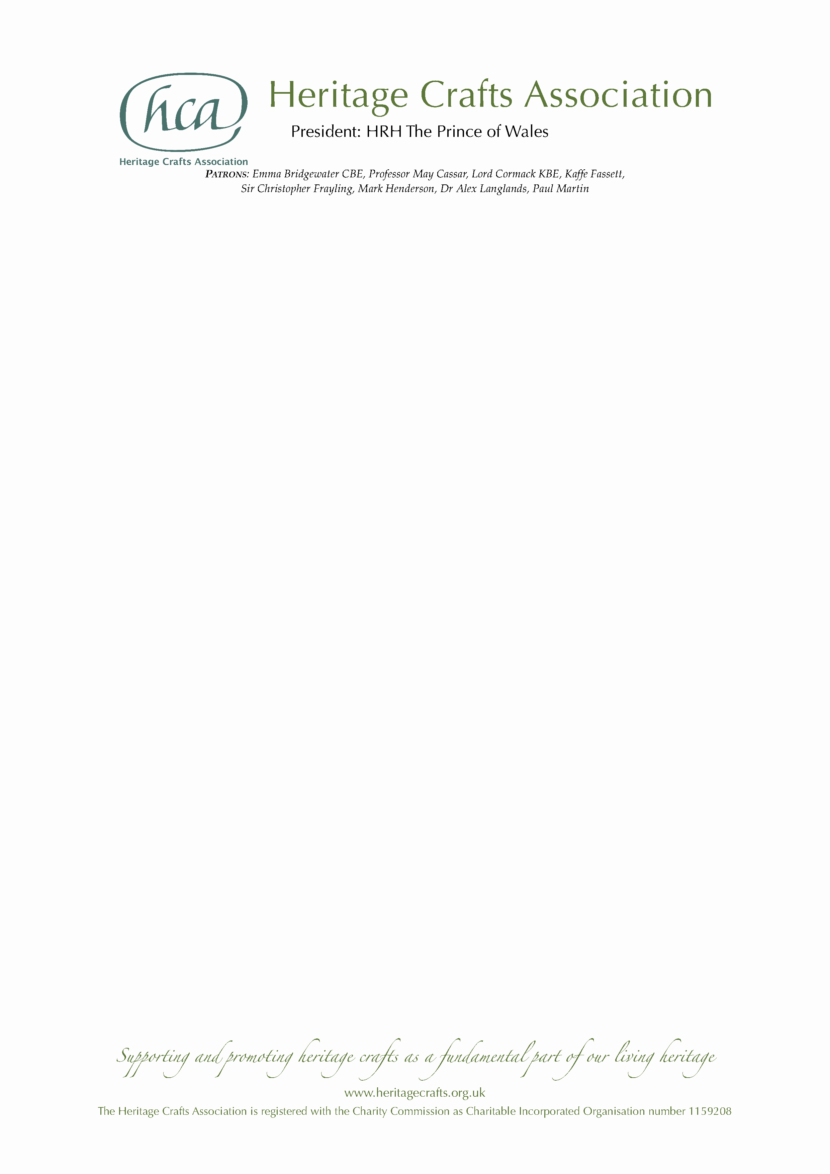

NEWS RELEASE

Monday 2 March 2020

President's Award for Endangered Crafts supported by HRH The Prince of Wales

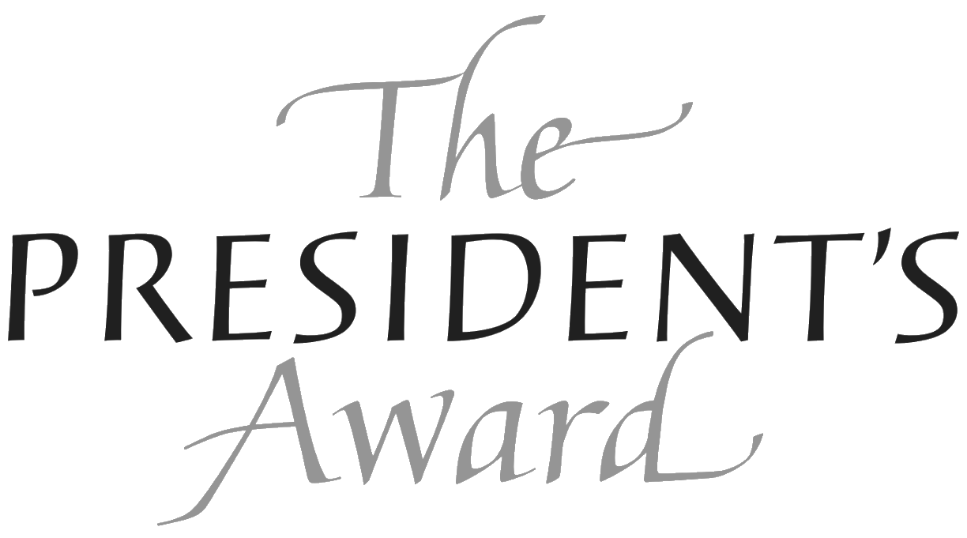
HRH The Prince of Wales has established a new award for endangered crafts through his patronage of the Heritage Crafts Association. Each year the President’s Award for Endangered Crafts will present £3,000 to a heritage craftsperson who will use the funding to ensure that craft skills are passed on to the future.

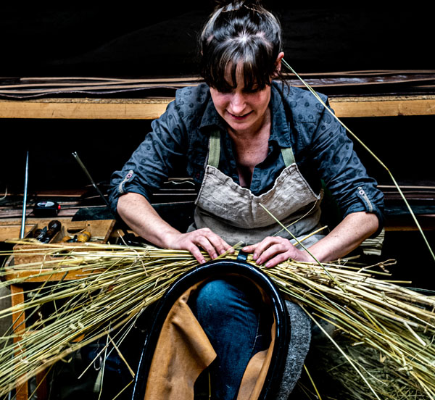
The Heritage Crafts Association (HCA) published the latest edition of its groundbreaking HCA Red List of Endangered Crafts last year, which revealed that there are 107 endangered crafts in the UK. Crafts deemed critically endangered range from bell founding and damask weaving to orrery making and reverse glass sign painting. Other endangered crafts include a number of musical instrument making crafts, including brass, woodwind and percussion instruments, harps and Northumbrian pipes.

Applicants for the President’s Award are invited to submit proposals to help secure the survival of their craft, which must be listed as ‘endangered’ or ‘critically endangered’ on the 2019 edition of the HCA Red List of Endangered Crafts.

The President’s Award will be presented at a special reception at Dumfries House, home of The Prince’s Foundation, as well as at a prestigious winners’ reception at the Houses of Parliament.

The Award judges are renowned advocates of craft skills:

- Patrick Grant, BBC The Great British Sewing Bee, Director of Norton and Sons and Community Clothing;
- Mark Hedges, Editor of Country Life;
- Kate Hobhouse, Chair of Fortnum and Mason;
- Patricia Lovett MBE, Chair of the Heritage Crafts Association; and





- Simon Sadinsky, Deputy Director of The Prince’s Foundation.

HCA Chair Patricia Lovett said:
“The UK has a hugely rich cultural heritage of craft skills which can be regarded as important as our great historical buildings and treasured objects – all the result of great craftsmanship. However we are in danger of losing a number of these crafts where our research has found that in some cases there are only one or two makers left. The Heritage Crafts Association hopes that by focusing on endangered crafts with this wonderful award initiated by our President, The Prince of Wales, the craft skills will be passed on to future generations.”

Applications are invited via www.heritagecrafts.org.uk/presidentsaward from those practising a craft listed as ‘endangered’ or ‘critically endangered’ on the 2019 edition of the HCA Red List of Endangered Crafts (www.heritagecrafts.org.uk/redlist). Applicants must explain how they will use the £3,000 award to help secure the survival of their craft. The closing date for applications is Friday 17 April 2020 at 5pm. For more information about the award, email HCA Operations Officer Daniel Carpenter at daniel@heritagecrafts.org.uk.

ENDS

Photo caption

Main photo:
- Kate Hetherington, horse collar and harness maker. Photo by Andrew Hobbs.

Judges:
- Patrick Grant, BBC The Great British Sewing Bee, Director of Norton and Sons and Community Clothing.
- Mark Hedges, Editor of Country Life.
- Kate Hobhouse, Chair of Fortnum and Mason.
- Patricia Lovett MBE, Chair of the Heritage Crafts Association.
- Simon Sadinsky, Deputy Director of The Prince’s Foundation.

Contact

For more information about The President’s Award, for additional photographs and for information about the Heritage Crafts Association contact Daniel Carpenter, HCA Communications Officer – daniel@heritagecrafts.org.uk

About the Heritage Crafts Association

Founded in 2009, the Heritage Crafts Association (HCA) is a Charitable Incorporated Organisation (CIO), the advocacy body for traditional heritage crafts. Working in partnership with government and key agencies, it provides a focus for craftspeople, groups, societies and guilds, as well as individuals who care about the loss of traditional crafts skills, and works towards a healthy and sustainable framework for the future. Its aim is to support and promote heritage crafts as a fundamental part of our living heritage.

www.heritagecrafts.org.uk

About the HCA Red List of Endangered Crafts

The HCA Red List of Endangered Crafts, created by the Heritage Crafts Association, was the first to rank traditional crafts in the UK by the likelihood they would survive the next generation. The 2019 edition of the Red List assessed 213 crafts to identify those which are at greatest risk of disappearing, of which four have been classified as extinct, 36 as critically endangered, 71 as endangered and 102 as currently viable.

The Red List shows that the craft knowledge, skills and practices that form an important part of our shared cultural heritage are – for a number of reasons – at risk of being lost. The HCA believes that these cultural assets are as important as unique heritage buildings and ancient beautiful landscapes and could provide future generations with fantastic opportunities to enrich their lives and the lives of others.

http://redlist.heritagecrafts.org.uk

